CHAPTER 18 Reproduction

*Animation.18: reproduction*

*Source & Credit:* [*wikispaces*](https://buffonescience9.wikispaces.com/UNIT+3+-+Cell+Reproduction)

Every species of organisms can reproduce new individuals of that species. In organisms, methods of reproduction are varied and some are quite complex. It is very important to the survival of a species or a population. Reproduction is the mechanism that- produces new generations and maintains a species-population.

Reproduction is of two types, asexual reproduction and sexual reproduction. Asexual reproduction requires only a single parental organism which gives rise to ofspring by mitotic cell division, during which the total chromosomes content of the cell is exactly replicated and passed on to daugher cells, so that the ofspring are genetically identical to the parent. Methods of asexual reproduction are ission, sporulation, budding, vegetative propagation, artiicial propagation, parthenogenesis and apomixis etc.

Sexual reproduction usually involves two parents. A fertilized egg is produced through the union of meiotically produced specialized sex cells (egg and sperm) from each parent. Meiosis or reduction division gives rise to gametes (gametogenesis) in which not only the chromosome number is halved (haploid) but reshuling of genes leads to recombination of genes. This not only maintains the chromosome number in a species but also produces genetic variations, an important factor in the survival and adaptation of a species or a population (Fig. 18.1).

In plants, if there isalternationof generations namely a diploid sporophyte and a haploid gametophyte, meiosis occurs during spore formation (sporogenesis).

In asexual reproduction, although increase in number of genetically alike individuals from a parent is very rapid but this is not an adaptive method and may at some stage jeopardize the survival of a species. Man has favoured this type of reproduction for his own needs, commonly in plants but now tissue culture technique in plants and cloning in animals are being adopted for producing organisms of valuable characteristics, without a change in their genetic make up. Cloning has been practised successfully but its disadvantages like rapid aging and low resistance to environmental stress and diseases are still the limitations for commercial ventures. Also it is still not being accepted socially and morally in general.

#### REPRODUCTION IN PLANTS

In plants both sexual and asexual reproduction are foun. In asexual reproduction layering, grafting, budding etc. are the artiicial modes.

In sexual reproduction, plants have **diplohaplontic life cycle** with alternating diploid sporophyte and haploid gametophyte generations. If the two generations are vegetatively similar, such alternation of generations is referred to as Evolution of pollen tube is an important step in isomorphic, and if they are dissimilar it is called land adaptation by the spermatophytes. Pollen heteromorphic. tube acts as vehicle for male gametes for their safe transport to female gamete in ovule in

Seed plants are predominatly present hostile land environment. Evolution of polletube is parallel to the evolution of seed and in s all around us due to their better sexual a tool of success for seed plants. reproduction, modiication of lower and inloresence for pollination, involving

gamete transfer by pollen tubes,food storage for developing embryo, protection by seed coats and dispersal with the help of fruit formation (angiosperms). Seeds are capable of enduring unfavourable conditions in dormant form (seed dormancy) and as soon as, conditions become favourable for establishing the seedling, it germinates.

*Animation 181:Reproduction*

*Source & Credit:* [*Ameoba Sisters*](http://http://www.amoebasisters.com/)

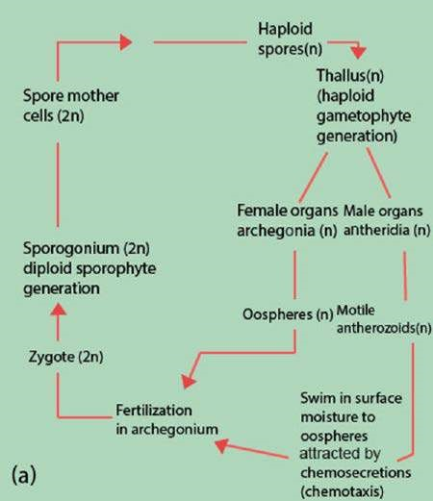

*Fig. 18.1 (a) Bryophyte life cycle. Note that the sporophyte is completely dependent upon the gametophyte.*

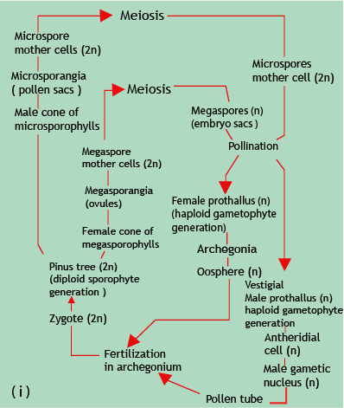

*Fig. 18.1 (b) Spermatophyte life cycles (i) Gymnosperm life cycle, Pinus sylvestris (Class Pinatae). (ii) Angiosperm life cycle.*

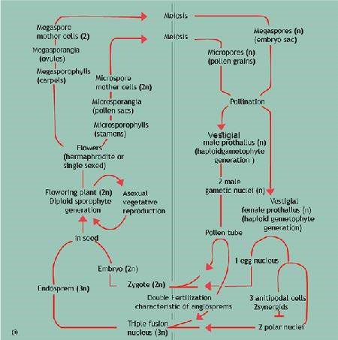

*18.1 (ii) Angiosperm life cycle*

##### Parthenocarpy

In some cases, fruit development proceeds without fertilization and thus no seed formation takes place e.g. banana, pineapples and some varieties of oranges and grapes. Such development is called parthenocarpy. It is due to hormonal imbalance; usually high auxin levels occur in these ovaries. Parthenocarpy is sometime artiicially induced for commercial purposes, by adding auxins in tomato, peppers etc.

##### Seed Dormancy

It is the special condition of rest, which enables an embryo to survive long periods of unfavourable environmental conditions, such as water scarcity or low temperature. During this period of rest the embryo ceases or limits its growth. This is of great survival importance to the plant in that it prevents the dormant seed from germinating in response to conditions such as a warm spell in winter. Germination or resumption of normal growth by a dormant embryo requires certain, very precise combinations of environmental cues, to avoid any accidental stimulus which may prove fatal later on.

##### Fruit set and Fruit ripening

Germinating pollen grain is not only an important structure for safe transfer of gametes and insurance for fertilization but also a rich source of auxins as well as commonly stimulating the tissues of the style and ovary to produce more auxin. This auxin is necessary for ‘fruit set’, i.e. retention of the ovary, which becomes the fruit after fertilization. Without it abscission of lowers normally occurs, leading to low fruit yields. After fertilization, the ovary and the ripe seeds continue to produce auxins which stimulate fruit development. Developing seeds are not only a rich source of auxins and gibberellins, but also of cytokinins.

These growth substances are mainly associated with development of the embryo and accumulation of food reserves in the seed and some times in the pericarp (fruit wall).

Fruit ripening is often accompanied by a burst of respiratory activity called the climacteric. This is associated with ethane production, which helps in ripening of the fruit.

##### Photoperiodism

Apart from photosynthesis and phototropic responses, another very important way in which light exerts its inluence on living organisms is through variations in day length called photoperiod. In plants, photoperiod and temperature afect lowering, fruit and seed production, bud and seed dormancy, leaf fall and germination.

Photoperiod afects lowering, when shoot meristems start producing loral buds instead of leaves and lateral buds.

Efect of photoperiodism was irst studied in 1920 by Garner and Allard. They studied that tobacco plant lowers only after exposure to a series of short days. Tobacco plant naturally lowers under same conditions, in autumn, but lowering could be induced by conditions artiicially to short days exposing. With further studies they were able to classify lowering plants into long-day plants, which require long days for lowering and day-neutral plants lower without being inluenced by photoperiod.

Later on, further studies indicated that it is really the length of the dark period which is critical. Thus short-day plants are really long-night plants. If they are grown in short days, but the long night is interrupted by a short light period, lowering is prevented. Long-day plants will lower in short days if the long night period is interrupted (Table 18.1)

*Animation 181:Photoperiodism*

*Source & Credit:* [*Leaving BIo*](http://http://leavingbio.net/plant%20responses.htm)

*Table 18.1 (a) Classiication of plants according to photoperiodic requirements for lowering*

|  |
| --- |
| Short-day plants (SDPs Long-day plants (LDPs) Day-neutaral plants (DNPs) |
| Flowering induced by dark Flowering induced by dark Flowering indepenedent periods longer than a critical periods shorter than a of photoperiod.  length, e.g. cocklebur 8.5 h; critical length, e.g. henbane tobacco 10-11h. 13h.  (Under natural conditions  equivalent to days shorter (Under natural conditions than a critical length, e.g. equivalent to days longer cocklebur 15.5 h; tobacco than a critical length, e.g.  13- 14h) henbane 11 h). e.g. cucumber, tomato,  e.g. cocklebur (Xanthium), e.g. henbane (Hyoscyamus garden pea, maize, cotton.  chrysanthemum, soyabean, niger), snapdragon, tobacco, strawberry cabbage, spring wheat,  spring barley. |

*Table 18.1 (b) Some phytochrome-controlled responses in plants.*

|  |  |
| --- | --- |
| General process efected | Red light promotes |
| Photoperiodism | Stimulates lowering in long-day plants. Inhibits lowering in short-day plants.  See lowering. |

Further experimentation also revealed that quantity of light is also inluenced by the quality of light. Cocklebur, a short day plant, will not lower if its long night is interrupted but experiments revealed that red light was efective in preventing lowering and far-red light reversed the efect of red light. It was also demonstrated that the last light treatment always determines the response. This response to light intensity and quality led to the discovery of blue pigment that is red light sensitive protein, the phytochromes.

Phytochrome exists in two forms i.e. P 660 and P 730. P 660 a quiscent form absorbs red light at a wave length of 660 nm and is converted to active P 730, P 730 absorbs far red light at 730 nm and is converted to P 660. In nature, the P 660 to P 730 conversion takes place in day light and P 730 to P 660 conversion occurs in the dark. Thus during the day a plant has P 730 phytochromes while during the night it contains more phytochromes in the form of P 660. The presence of either form provides the plants with a means of detecting whether it is in a light or dark environment. The rate at which P 730 is converted to P 660 provides the plant with a “clock” for measuring the duration of darkness.

It has been found that red light inhibits lowering the short day plants but promotes lowering in long day plants, under conditions during which lowering normally takes place. This observation led to hypothesize that the P730-P660 interconversion might be the lant time - regulator for lowering. According to this hhypothesis, p 730, converted from P 660 by the absorption of red light, would inhibit lowering in short day plants but promote lowering in long day plants. Because P 730 accumulates in the day and diminishes at night, short day plants coud lower only if the night were long enough, during which a great amount of P730 would not be completely inactivated, so that enough P 730 would remain at the end of night to promote lowering. But now it is generally agreed that the time measuring phenomenon of lowering is not totally controlled by the interconversion of P 660 to P 730. Other factors, like presence or absence of light and length of dark, or light period also play an important role in lowering. Phytochromes seems to be responsible for the detection of either light or darkness. The biological clock once stimulated causes production of lorigen hormone in leaves, which travels through phloem to the loral buds, initiating lowering.

###### Vernalisation

Biennials and perennial plants are stimulated to lowering by exposure to low temperature. This is called **vernalisation**. The low temperature stimulus is received by the shoot apex of a mature stem or embryo of the seed but not by the leaves as in photoperiodism.

For some plants, vernalisation is an absolute requirement or in some cases it simply assists in inducing lowering. The duration of low temperature (chilling) treatment required varies from four days to three months.

Temperature around 4°C is found to be very efective. It stimulates the production of “vernalin” hormone which induces vernalisation, it is now believed that vemalin is nothing special but actually is gibberellin.

Photoperiodism and vernalisation serve to synchronise the reproductive behaviour of plants with their environment, ensuring reproduction at favourable times of year. They also ensure that members of the same species lower at the same time, encouraging cross pollination for genetic variability.

#### REPRODUCTION IN ANIMALS

Animals like plants also reproduce both asexually as well as sexually. But asexual reproduction is less common in animals as compared to plants. Binary ission, multiple ission (animal like protoctists) budding (Hydra) parthenogenesis, tissue culturing, cloning and identical twins are the common asexual methods of reproduction.

In honeybee males are haploid and produce sperms by mitosis.

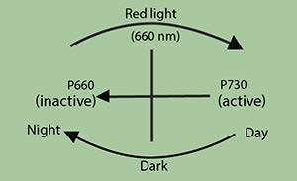

##### Asexual Reproduction

Parthenogenesis is deined as the development of an egg without fertilization, ants, bees and wasps are good examples. In the honeybees, males (or drones) develop from unfertilized eggs. The queen bee, though carrying male gametes from male, has the ability to lay eggs that have not been fertilized. The sperms she receives from a drone bee are stored in a pouch closed of by a valve. The eggs may be fertilized or may not be fertilized from the stored sperms. The haploid egg develop into haploid ofspring, it is called haploid parthenogensis.

In some cases e.g. in aphids, diploid parthenogenesis may occur, in which the egg- producing cells of the female, undergo a modiied form of meiosis involving total non-disjuction of the chromosomes, they retain the diploid number of chromosome. Egg (diploid) develops into young females. Parthenogenesis has the advantage of accelerating the normal reproductive rate.

###### TISSUE CULTURING AND CLONING

In tissue culturing technique in plants, cambium tissue excised from plants can be stimulated by the addition of nutrients, cytokinins, and IAA (indole acetic acid). These cells show continuous growth and diferentiate into a new plant, genetically identical to their parents.

Tissue culture is now widely used for the rapid propagation of desired varieties or for varieties diicult to propagate by cuttings. Similar techniques have been developed for the tissue culture of animal cells.

In lowering plants, one form of parthenogenesis is called apomixis. In this a diploid cell of the ovule, either from the nucellus or megaspore, develops into a functional embryo in the absence of a male gamete. The rest of the ovule develops into the seed and the ovary into the fruit.

Organisms produced from a single cell by subculturing (cloning) are called clones. In animals and especially among vertebrates, a nucleus from the somatic cell is removed and introduced into an egg cell, whose own nucleus has been destroyed by ultra violet radiation. The egg with transplanted diploid somatic cell nucleus develops into an organism, genetically identical to the parent who has contributed the nucleus.

The cloning of desirable animals such as prize bulls, race horses etc. might be as useful as cloning of useful varieties of plants.

However, the application of the technique to humans would be open to serious moral questions. Theoretically any number of genetically identical copies of the same man or woman might be made. The use of cloned cells allows the quantitative study of the action of hormones, drugs and antibodies to be made on cells. Such a technique is a useful substitute for investigating the efect of drugs, cosmetics and pharmaceutical products on animal cells without exposing laboratory animals to these chemicals.

Cloning has the advantage that all the ofspring behave similarly, but if an environmental hazard develop (like an out break of a disease), non resistant strains are present to lessen the impact. Also the degree to which environment inluences clone development is not fully known and any cloned cell would have to go through all the phases of development once again including embryo, fetus, baby and child hood (in case of human beings).

#### IDENTICAL TWINS

In higher vertebrates including man, zygote after fertilization undergoes cleavage (cell division by mitosis). When embryo is at two celled stage, the two blastomeres, instead of remaining together, may separate and behave as two independent zygotes, each giving rise to a new individual. Both the organisms are products of mitosis, thus they have identical genetic make up and are called identical twins. They are produced mitotically (asexually).

In some cases, more than one egg is produced by the female and all these eggs are independently fertilized forming two or more zygote. These zygotes develop into new ofsprings, but with diferent genetic combinations. Such a twins or triplets are called fraternal twins or triplets. They are produced sexually.

#### SEXUAL REPRODUCTION

It is thought that asexual method of reproduction is a primitive form of reproduction than the sexual reproduction. At a later stage, a mechanism have evolved leading to production and union of gametes. Meiosis and genetic recombination played a major role in the development of more complex forms of life and types of gametes, from identical gametes (isogametes) to the heterogametic stage of motile male gametes (sperms or antherozoid) and non-motile female gametes eggs (ova). Sexual reproduction has advantage over asexual reproduction which is elaborated in the following table 18.2.

**Table 18.2**

|  |
| --- |
| Asexual reproduction Sexual reproduction (omitting bacteria) |
| One parent only. Usually two parents.  No gametes are produced. Gametes are produced. These are  haploid and nuclei of two gametes fuse (fertilization) to form a diploid zygote.  Meiosis absent. Meiosis is present at some stage in life  cycle to prevent chromosome doubling in every generation.  Ofsprings identical to parent. Ofsprings are not identical to parents. They show genetic variation as a result of genetic recombination  Commonly occurs in plants, less Occurs in the majority of plant and animal diferentiated animals and micro- species.  organisms Absent in more diferentiated animals.  Less rapid increase in number.  Often results in rapid production of large number of ofsprings. |

Both in animals and plants, evolution of sexual reproduction also lead to the diferentiation of sexes (male or female). Organisms are either having one sex (unisexual) or both the sexes (hermaphrodite or bisexual). Advance mode of sexual reproduction has unisexuality in animals but in plants bisexuality in general is retained. Despite the bisexuality (tape worm, earthworm etc.), cross fertilization is ensured for maintaining the advantage of genetic recombination.

Fertilization is the process which leads to the union of gametes. Fertilization may occur outside the body (external fertilization) or inside the body of the female (internal fertilization).

External fertilization occurs in aquatic environment where male gametes can swim towards the female-gametes in water medium. Development is also external due to the constant / stable conditions of water (frog, ish etc.)

In terrestrial conditions, fertilization is internal. Sperms are lodged in the female body where fertilization occurs. This may lead to external development as in reptiles and birds. They lay shelled eggs to protect the developing embryo from harsh terrestrial conditions. Such animals are called oviparous.

In mammals, internal fertilization leads to internal development and development of embryo is accomplished inside the female body, which gives birth to young one - such animals are called **viviparous**.

In some mammals like duckbill platypus and spiny ant-eater internal fertilization leads to internal development of young one in a shelled egg and when development is completed, shelled egg is laid which hatches to ofspring This is called ovoviviparous condition.

Viviparous and ovoviviparous animals provide more protection to their young one during development. Nourishment is provided either through stored food in the egg or through placenta by the mother.

#### REPRODUCTION IN MAN

Male and female have separate reproductive systems.

##### (a) Male Reproductive System

Male reproductive system consists of external genitalia which consist of a pair of testes which lie outside the body, in the sac-like scrotum and male copulatory organ which is used to transfer the sperms into the female reproductive tract. Each testis consists of a highly complex duct system called seminiferous tubules, in which repeated division by the cells of the germinal epithelium produce spermatogonia. These increase in size and diferentiate into primary spermatocytes which undergo meiotic division to form secondary spermatocytes and spermatids. Eventually, the spermatids diferentiate into mature sperms. Fluid secreted by sertoli cells provides liquid medium, protection and nourishment to sperms while they are in tl e tubules.

(Fig. 18.2 a,b, Fig. 18.3). The sperms are then transferred to the main duct of the male reproductive tract, the vas deferens, which forms highly convoluted epididymis. The sperms then pass through the urinogenital duct and ‘are discharged out.

*Animation 181:Sexual reproduction in plants Source & Credit:* [*Leaving BIo*](http://http://leavingbio.net/plant%20responses.htm)

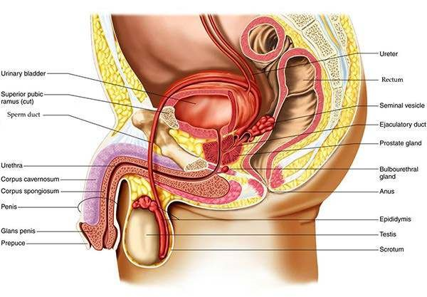

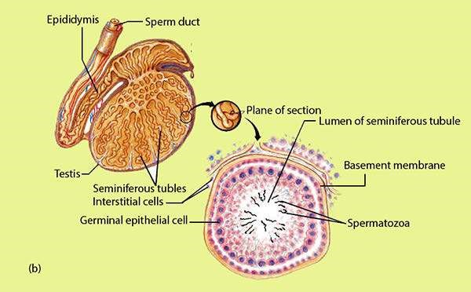

*Fig. 18.2 The human male reproductive system*

*The male reproductive system consists of two testes that produce sperms, ducts that carry the sperms, and various glands.*

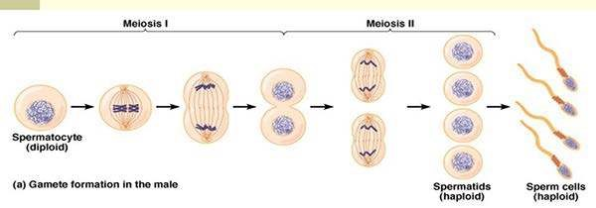

*Fig. 18.3 Gamete formation*

Between the seminiferous tubules are interstitial cells which secrete testesterone. This hormone is essential for the successful production of sperms and also controls the development of male secondary sexual characteristics during puberty.

##### (b) Female Reproductive System

The female reproductive system consists of ovaries, oviducts, uterus and the external genitalia (18.4).

A pair of ovaries lies within the body cavity of the female. Germ cells in the ovary produce many oogonia which divide mitotically to form primary oocytes. These are enclosed in groups of follicle cells. The primary oocyte divides meiotically into the haploid secondary oocyte and irst polar body. Second meiotic division in the oocyte proceeds as far as metaphase but is not completed until the oocyte is fertilized by the sperm. In human only one ovum is usually discharged from the ovary at one time, this phenomenon is called ovulation.

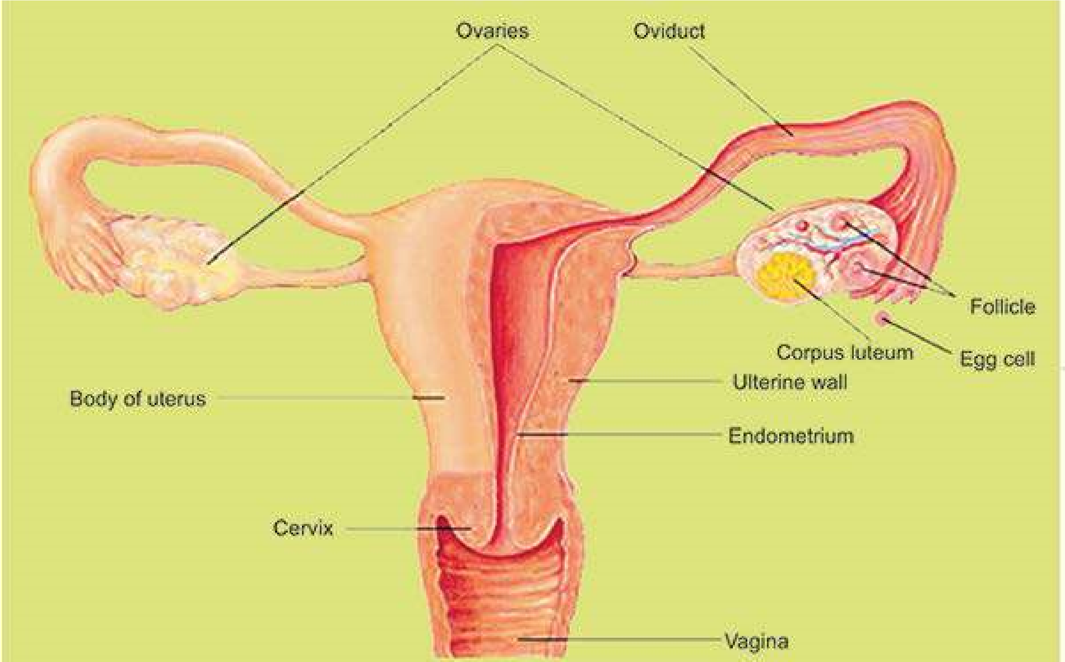

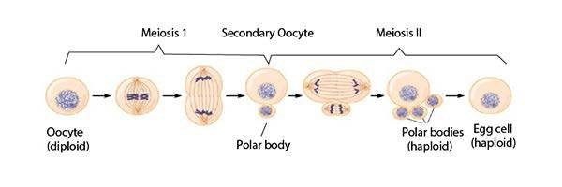

*Fig.18.4 (a)The human female reproductive system (b) Gamete formation*

The ovum is then transferred to the oviduct generally called fallopian tube Or uterine tube. The uterine tube opens into the uterus. The fertilization of the ovum takes place in the proximal part of the oviduct. The fertilized ovum (zygote) enters the uterus where it is implanted (conceived) and undergoes further development. A placenta is established between the uterine and foetal tissues for the exchange of oxygen,carbondioxide, waste, nutrients and other materials. Uterus opens into the vagina through cervix. Urethra and vagina have independent openings to the exterior.

**Female Reproductive cycle:** In females the production of egg is a cyclic activity as compared to males, where gamete production and release is a continuous process beginning at puberty and lasting throughout life.

In human females, the periodic reproductive cycle is completed in approximately 28 days and involves changes in the structure and function of the whole reproductive system. It is called the menstrual cycle and can be divided into four phases. The events of the menstrual cycle involve the ovaries (ovarian cycle) and the uterus (uterine cycle) and these are regulated by pituitary **gonadotropins.**

Primary steps in female reproductive cycles are:

1. The pituitary gland on the onset of puberty, releases follicle stimulating hormone (FSH) which stimulates the development of several primary follicles. Only one of these follicles continues to grow with its primary oocytes while the rest break down by a degenerative process known as follicle atresia.
2. The ovary, under the stimulus of FSH, also produces estrogen hormone.-This, on one hand, stimulates the endometrium (internal living of the uterus wall) and vascularizes it, and on the other hand, inhibits the secretion of FSH from pituitary gland.
3. Decrease of FSH and increase of estrogen, causes the pituitary gland to secrete luteinizing hormone (LH) which induces ovulation - the release of ovum from the follicle.
4. The follicle cells, after release of the egg. are modiied to form a special structure called corpus luteum. This yellowish glandular structure starts” secreting hormone called progesterone. This hormone develops the endometrium and make it receptive for the implantation of the zygote (placenta formation).
5. If fertilization does not occur, the corpus luteum starts degenerating. The progesterone secretion diminishes and its supporting efect on the spongy endometrium is reduced, which sufers a breakdown. This causes the discharge of blood and cell debris known as menstruation. This stage usually lasts for 3 - 7 days (Fig 18.5)

Oestrous cycle is a reproductive cycle found in all female mammals except human being. In this cycle, the estrogen production prepares the uterus for conception partly and also follicle develops ova. At this stage, female needs a physical stimulus of mating for ovulation. She exhibits the desire for mating or is said to be on “heat”

The cycle is thus completed and the uterus is ready to enter into the next cycle. The human menstrual cycle generally repeats every 28 days although there is considerable variation in diferent individuals or even within the same individual at diferent times of her age. The end or complete stop of the menstrual cycle is called menupause, after which the female stops producing the ova.

Malnourishment and emotional stresses efect the female reproductive cycle, which may be disturbed. The cycle is not completed in its normal 28 days.

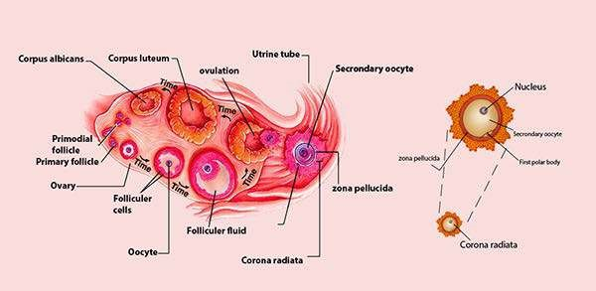

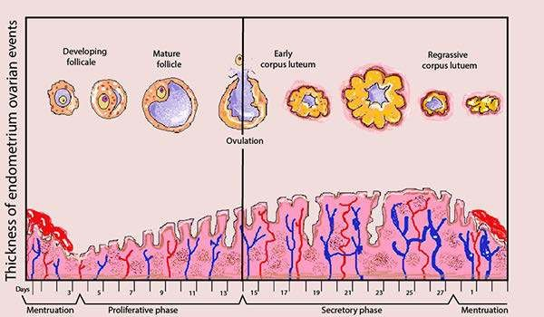

Fig. 18.5 The ovarian and uterine cycles in human female

The release of a secondary oocyte (ovulation) is timed to coincide with the thickening of the lining of the uterus. The uterine cycle in humans involves the preparation of the uterine wall to receive the embryo if fertilization occurs. Knowing how these two cycles compare, it is possible to determine when pregnancy is most likely to occur.

**Birth:** The total gestation period (pregnancy) is usually about 280 days.

Once the placenta is established, it starts secreting the progesterone hormone which maintains the pregnancy. Any disturbance in its secretion may lead to premature birth or miscarriage. Human embryo remains enclosed in amniotic sac illed with anmiotic luid which is protective and shock absorpitive.

During this period, pituitary gland produces luteotropic hormone (LTH). Placenta also secretes human placental lactogen. Both these hormones stimulate mammary development in preparation for lactation.

From beginning of the 3rd month of pregnancy, the human embryo is referred to as the fetus. Most of the major organs are formed by the 12th week of pregnancy and the remainder of the gestation period is taken up by growth.

It was thought that hormonal activities within the mother i.e. decrease in progesterone level onset the birth. But recent evidence suggest that there is a high degree of fetal involvement in the timing of birth. The initial stage of birth is the result of the stimuli from the fetal pituitary. The ACTH released from fetal pituitary stimulates the fetal adrenal gland to release corticosteroids, which cross the placental barrier and enter the maternal blood circulation causing a decrease in progesterone production. The reduction of progesterone level, stimulates the pituitary gland to produce oxytocin hormone. This induces labour pains, i.e. contraction of the uterus wall. The release of oxytocin occurs in “waves” during labour and provides the force to expel the fetus from the uterus.

The cervix dilates and the uterine contractions spread down over the uterus and are strongest from top to bottom. Thus, pushing the baby downward leading to the delivery of the baby. The umblical cord is ligated and baby is released from the mother.

Within 10-45 minutes after birth, the uterus contracts and separate the placenta from the wall of the uterus and placenta then passes out through the vagina. This is called after birth. Bleeding, throughout this period, is controlled by the contraction of smooth muscle ibers which completely surround all uterine blood vessels supplying the placenta. Average loss of blood is about 350 cm3.

#### TEST TUBE BABIES

Recent biotechnical advantages has led to many improvements in human life. One of the important aspect is the test tube babies.

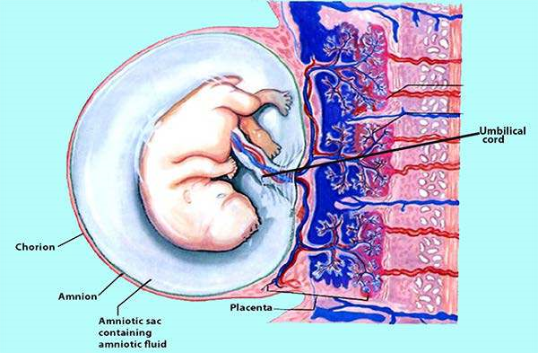

Fig. . 18.6 Placental structure

The embryonic blood vessels that supply the developing child with nutrients and remove the metabolic wastes are separated from the blood vessels of the mother. Because of this separation, the placenta can selectively ilter many types of incoming materials and microorganisms.

Parents which are unable to enjoy the normal process of fertilization and birth of their ofspring due to some physiological and physical abnormalities in any of the two parents are being beneited with this method.

Parental sperm and ovum is fertilized in vitro - outside the female body and then the zygote is implanted back into the mother uterus, placenta establishes and remaining development takes place in the body of the mother leading to normal birth.

#### SEXUALLY TRANSMITTED DISEASES (STD)

Unhealthy attitudes and low moral values sometimes lead to serious complication. The carrier may transmit this disease to their healthy partners.

##### (I) Gonorrhoa

It is caused by a gram positive bacterium *Neisseria gonorrhoeae*, mainly afecting the mucous membrane of urinogenital tract. New born infants may acquire serious eye infections if they pass through the infected birth canal. It is highly contagious through sexual contacts.

##### (ii) Syphilis

It is caused by a spirochaete, *Treponema pallidum*. It damages the reproductive organs, eyes bones joints, central nervous system, heart and skin. Sexual contact is the major source of its dissimination.

##### (iii) Genital Herpes

It is caused by a herpes simplex type 2 virus, most frequently transmitted by sexual contact causing infection of the genitalia. It produces genital soreness and ulcers in the infected areas. In infected pregnant woman, virus can be transmitted to infant during birth, causing damage to eyes and CNS of the infant.

#### AIDS (Acquired Immune Deiciency Syndrome)

You are already familiar with this dangerous disease. Sexual contact is one of the major sources of its spread.

**Control :** The above dreadful sexual diseases can be controlled and prevented by avoiding sexual contacts with carrier or diseased person and adopting the hygienic conditions. The treatment involves medication for a long period except AIDS at present.

##### Exercise

**1**

**. Fill in the blanks.**

1. Asexual reproduction requires only a single ____________organism
2. Sexual reproduction usually involves __________________ parents. 3. Phytochromes are the special_________ sensitive pigments
3. External fertilization occurs in_________ environment.
4. ____________ and _______animals provide more protection to their young one during development
5. A placenta is established between the uterine and__________ tissues for the exchange of oxygen.
6. The reduction of progesterone level, stimulates the_________gland to produce oxytocin hormone.

**Q.2 Write whether the statement is true or false and write the correct statement if false.**

1. Asexual reproduction involves mitotic cell division.
2. Asexually produced ofspring are genetically identical to their parents.
3. Sexual reproduction involves single parent.
4. Sexually produced ofspring are identical to their parent.

**Q.4. Short questions**

1. What changes occur in ovulation and menstruation during pregnancy?
2. What is the diference between oogenesis and spermatogenesis in humans?
3. How is a seed formed?
4. What is the importance of seed in the life cycle of a plant.

**Q3. Extensive questions.**

1. What structures are associated with the human female reproductive system? What are their functions?
2. What are the functions of placenta during pregnancy?
3. Describe human menstrual cycle.
4. Write notes on the following:
   1. Parthenogenesis
   2. Herpes Genitalia
   3. Asexual reproduction
   4. Seedless fruits

CHAPTER

19 GROWTH AND

# DEVELOPMENT

*Animation 19: Homeostasis*

[*Source & Credit: Wikispaces*](http://anatomyeshs.wikispaces.com/Ch.16+Respiratory+System)

In the course of its life cycle an organism changes from a fertilized egg into an adult. As development proceeds, all sorts of the changes take place. The most obvious change is growth. The progressive changes which are undergone before an organism acquires its adult form constitute embryonic development. Growth is the permanent and irreversible increase in size that occurs as an organism mature.

## GROWTH AND DEVELOPMENT IN PLANTS

In plants growth and development involve cell division, elongation and diferentiation of cells into tissues and then organs. Growth is an irreversible increase in size and development is a programmed series of stages from a simpler to more complex form. As development proceeds, cellular diferentiation of structure and function takes place.

A plant has a growth pattern called **open growth**. Throughout life, the plant adds new organs such as branches, leaves and roots, enlarging from the tips of roots and shoot but the rate of growth is not uniform throughout the plant body. At the beginning, the growth is slow, but gradually it becomes rapid, attains a maximum, then gradually slows down. In vascular plants, growth occurs through the activity of meristems. Meristems are young tissues or group of cells that retain the potential to divide. In lower plants, the entire plant body is capable of growing, but in higher plants, the entire plant body is not capable of growing but growth is limited to certain regions known as growing points.These growing points consist of groups of cells which are capable of division, these growing points are called meristems. These meristematic cells are located at the stem and root and they are of the following types. **(i) Apical Meristems**

The apical meristems are found at the tips of roots and shoot and are primarily concerned with the extension of plant body. These are perpetual growth zones found at the apices of roots and stems. They are responsible for increase in the number of cells at the tips of roots and stem, so they play important role in primary growth (Fig 19.1).

*Animation 19.1: Apical Meristems*

*Source & Credit:* [*Animated Abstarct*](http://http://www.cas.miamioh.edu/~meicenrd/Anatomy/Ch5_CellTypes/meristem.html)

### (ii) Intercalary Meristems

These are the parts of apical meristem which get separated from apex by permanent tissues. They are situated at the bases of internodes in many plants. They play important role in the production of leaves and lowers. These are of temporary nature.

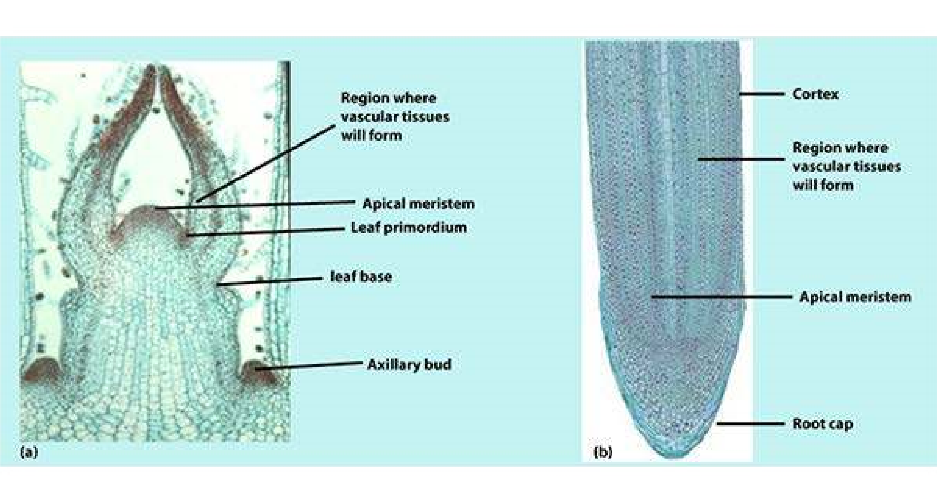

*Fig. 19.1 Photomicrographs of the apex of a shoot (a) and a root (b).*

#### (iii) Lateral Meristems

Lateral meristems are cylinders of dividing cells. They are present in dicots and gymnosperms. Vascular and cork cambium are the examples of lateral meristem. They play an important role in the increase in diameter of stem and root and in secondary growth are determinate i.e. they grow to certain size and then stop e.g. leaves, lowers and fruits; while others are indeterminate i.e. they- grow by meristems that continually replenish themselves, remaining youthful e.g. vegetative root and stem.

**Types of Growth:**

1. **Primary Growth :** Primary’ tissue is added by the apical meristem
2. **Secondary Growth :** Secondary tissue is added by the intercalary or vascular cambium leading to increase in thickness.

**Phases of Growth :** Growth of multicellular plant is divided into four phases, cell division, elongation, maturation and diferentiation.

During **cell division**, the number of cells increase by mitosis. It occurs at the tip of root and shoot where cells are small, have spherical nuclei lying in the center of cytoplasm, which is non-vacuolated. As a result of cell division, each daughter cell proceeds to enlarge. Synthesis of cytoplasm and cell wall material also takes place in this zone.

A little distance from apex of root and shoot lies the **zone of elongation** and is only of few millimeters in length. During elongation the cell volume increases upto 150 fold due to uptake of water. Plasticity of the cell wall increases and wall pressure is reduced. Synthesis of new cytoplasm and cell wall material proceeds on.

During **maturation**, the inal size of a given type of a cell is attained.The cells which develop into pith, cortex and certain other tissues do not elongate further along the axis, while other cells like ibers and tracheids elongate lengthwise more than in other direction.

When the cell enlargement ceases, the process of **diferentiation** starts. During this growth phase the walls of cells become thicker, the walls of many kinds of cells and tissues become pitted; thickening appear on the walls of xylem vessels, cells of various tissues difer in spatial dimensions and many new structural features develop. (Fig

19.2**)**

##### Conditions of Growth

The growth rate is inluenced by number of factors both external and internal. External factors are temperature, light, oxygen, carbon dioxide, water, nutrition etc. while internal factors are hormones, vitamins etc.

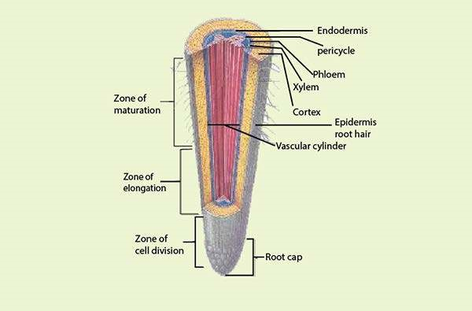

*Fig. 19.2 The root tip is divided into four zones.*

##### (A) Externa! factors

1. **Temperature :** Temperature inluences the rate of growth within a certain range (0-35°C). Normally rate of growth increases with rise of temperature and decreases with decrease in temperature. For maximum growth, the optimum temperature is 25-30°C and it is least at 5-10°C. But at a very high temperature (35-40°C), the rate of growth stops and the plant may die.
2. **Light :** Light plays very important role in the growth of plants. By light, we mean the fractions of light, which is absorbed by plant during photosynthesis. Generally, light inluences growth in three ways; intensity, quality and duration.

The increase in intensity of light increases the number of cell divisions. The red light favours elongation of cells and blue light enhances cell division but retards cell enlargement. Similarly, ultraviolet rays also retard cell elongation. Duration of light affects the growth of vegetative and reproductive structures. It also plays a role in inducing or suppressing lowering. The phenomenon is termed as **photoperiodism**.

1. **Oxygen** : For successful growth, regular supply of oxygen is necessary. Without oxygen, no metabolic activity is possible and no growth takes place. A very high supply of oxygen however, inhibits growth.
2. **Carbon Dioxide :** We know carbon dioxide is essential for carrying out normal process of photosynthesis but a very high concentration of it can retard growth.
3. **Water :** By absorbing water, the cells elongate. The plant growth ceases in the absence of water.
4. **Nutrition :** Nutrients supply energy to growing plants. With the increase in nutrition, growth increases, whereas decrease in nutrition causes retardation of growth.

**(B) Internal Factors**

1. Hormones : Plant hormones also inluence growth e.g. Indole-3-acetic acid / (IAA) causes elongation of cells.
2. **Vitamins** : Vitamins are orgasmic compounds synthesized within the plant bodies in the presence of light. If the plants are grown in dark, the vitamin deiciencies are induced and growth of plant body ceases.

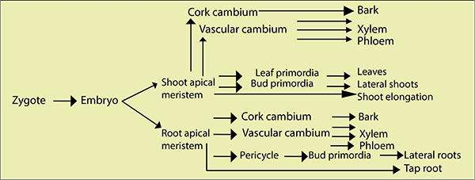

*Fig. 19.3Graphic representation of growth and diferentiation in plants*

##### Differentiation

As you have studied, once a seed has germinated, the plant’s further development depends on the activities of the meristematic tissues, and we know that shoot and root apical meristems give rise to all cells of the adult plant. Diferentiation is the formation of specialized tissues, which can be considered to occur in plant in ive stages (Fig 19.3).

**Stage 1** Represents the formation of embryo.

**Stage 2** Within the embryo, shoot and root apical meristems are recognized.

**Stage 3** Cambium is recognized, it is responsible for secondary growth.

**Stage 4** There is production of leaf primordial (these are the cells committed to become leaves, shoot or roots). Root primordia develop from the root cambium, called pericycle. Leaf and shoot primordia develop directly from apical meristematic cells.

**Stage 5** Fully diferentiated tissues and structure are formed including xylem, phloem, leaves, shoots and roots.

##### Growth Correlations

The development of a plant is usually correlated with its growth and diferent organs growing at diferent rates in diferent directions and the development of diferent parts takes place. Such reciprocal relationship is known as **correlation**.

One of the most important correlative efect in plants is **apical dominance**. In many plants, only apical bud grows while growth is suppressed in lower axillary buds. In an experiment, when apical bud was removed, the growth in the lower buds was inhibited. So active shoot apex controls the development of lateral buds. Thus, the auxin of the terminal bud is responsible for inhibiting the growth of lateral buds by a phenomenon known as apical dominance (Fig 19.4). Later Thimann and Skoog in 1934 performed experiments and showed that **apical dominance** was caused by auxin difusing from the apical bud which inhibited the growth of lateral shoots is called **inhibitory efect**. The removal of apex releases the lateral buds from apical dominance. It is called **compensatory efect.**

Research has also indicated that not only auxin causes apical dominance, cytokinins also play important role in apical dominance and in many cases if cytokinins are applied directly on the inhibited bud, it allows lateral buds to be released from apical dominance. It is also seen that those plants that have dense growth of lateral branches, have very little apical dominance. As far as practical application of apical dominance is concerned, it plays an important role in tap root development, and the inhibition of sprouting of lateral buds (eyes) in potato tuber by applying synthetic auxin. In the later case, the sprouting of eyes is prevented and storing period is increased from one to three years (Fig. 19.4).

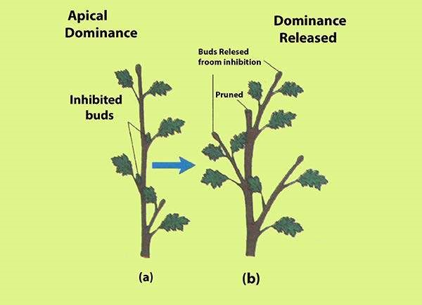

*Fig. 19.4 Apical Dominance : The Inluence of Auxin*

###### GROWTH AND DEVELOPMENT IN ANIMALS

Embryology is the study of growth and diferentiation undergone by an organism in the course of its development from a single fertilized egg into a highly complex and an independent living being like his parents.

Development is an ordered sequence of irreversible steps, with each step setting up the necessary conditions for the next step. Since all animals are somehow related through the process of evolution, there are some similarities in their various forms of development. Here, we will see a broad outline of the early stages of development.

This can be described in terms of several stages, depicted below:

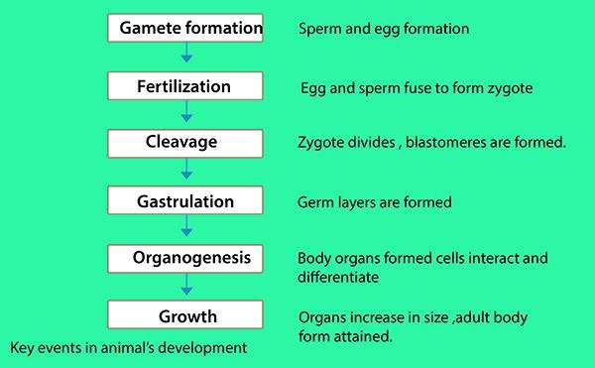

Development of Chick

The development of chick has been taken as a basic scheme of development. It will provide basis for understanding the early diferentiation of the organ systems and the fundamental process of body formation, which is common to all vertebrates.

**Fertilization and Incubation :** The chick egg (called the yolk) is surrounded by various accessory coverings secreted by the female reproductive tract.

Fertilization is internal and normally takes place just as ovum is entering the oviduct. The shell is secreted as the egg passes through the shell gland (the uterus).

When an egg has been laid, the development ceases unless the temperature of egg is kept nearly up to the body temperature of the mother. In incubating eggs artiicially, the incubators are usually regulated at temperature between 36-38°C. At this temperature, the chick completes development and is hatched on the twenty irst day.



*Fig. 19.5 Cleavage stages in chick*

*Animation 19.2: Development in Chick*

*Source & Credit:* [*Backyard Chicken*](http://http://www.backyardchickens.com/t/455596/chick-development-in-the-egg)

**Cleavage :**

Immediately after fertilization, the egg undergoes a series of mitotic divisions, called cleavage. In bird’s egg the process of cell division is conined to the small disc of protoplasm lying on the surface of the yolk at the. animal pole. This type of cleavage is referred as discoidal cleavage. The cleavage furrows start in the clear cytoplasmic region (Fig 19.5). The irst two cleavage planes are vertical while the third runs horizontally parallel to the surface and thus cuts underneath the cytoplasm and separates it from the yolk. The successive cleavages become irregular and number of cells increase. **Morulla :** Cleavage results in the formation of a rounded closely packed mass of blastomeres. This is morula, it consists of a disc shaped mass of cells two or more layers in thickness (blastoderm) lying close to the yolk. In the center of the blastoderm, the cells are smaller and completely deined while those at the periphery, are lattened, and larger.

**Blastulla :**

The morula stage is short-lived and soon changes into blastula and is characterized by the presence of a segmentation cavity or blastocoele. The discoidal cap of cells above the blastocoele is called **blastoderm**. The marginal area of the blastoderm in which the cells remain undetached from the yolk and closely adherent to it is called the zone of junction (Fig 19.6).

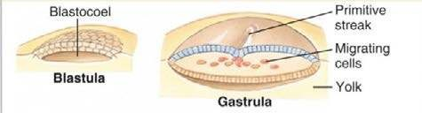

*19.6: BIastuia and gastrula stages in embryo of chick*

**Gastrulation :** It is characterized by the movement and rearrangement of cells in the embryo. During gastrulation, the blastoderm splits into two layers: an upper layer of cells called **epiblast**, and a lower layer of cells called **hypoblast**. The epiblast is mainly presumptive ectoderm and mesoderm (Fig 19.7). The hypoblast is mainly presumptive endoderm because hypoblast cells grow outward over the surface of the yolk, then downward around it to form the endodermal lining of a yolk sac. At this stage, the central cells of blastoderm can be separated from the yolk, under these central cells a pool of luid develops, raising them of the yolk and giving the area a translucent appearance - the **area pellucida**, while the peripheral part of the blastoderm where the cells lie unseparated from the yolk is termed as area opaca, the white area that transmits light. The upper layer of the blastoderm consists of the presumptive mesoderm and ectoderm.

###### Notochord and Mesoderm Formation

In the chick, the mesodermal cells do not invaginate as in amphibians, but migrate medially and caudally from both sides and create a mid line thickening called primitive streak (which grows rapidly in length as more and more presumptive mesodermal cells continue to aggregate in the middle. All this results in the change of shape of blastoderm, (it changes from circular to pear shaped).

*Animation 19.2: Mesoderm Formation*

*Source & Credit:* [*UNSW Embryology*](http://https://embryology.med.unsw.edu.au/embryology/index.php/Mesoderm)

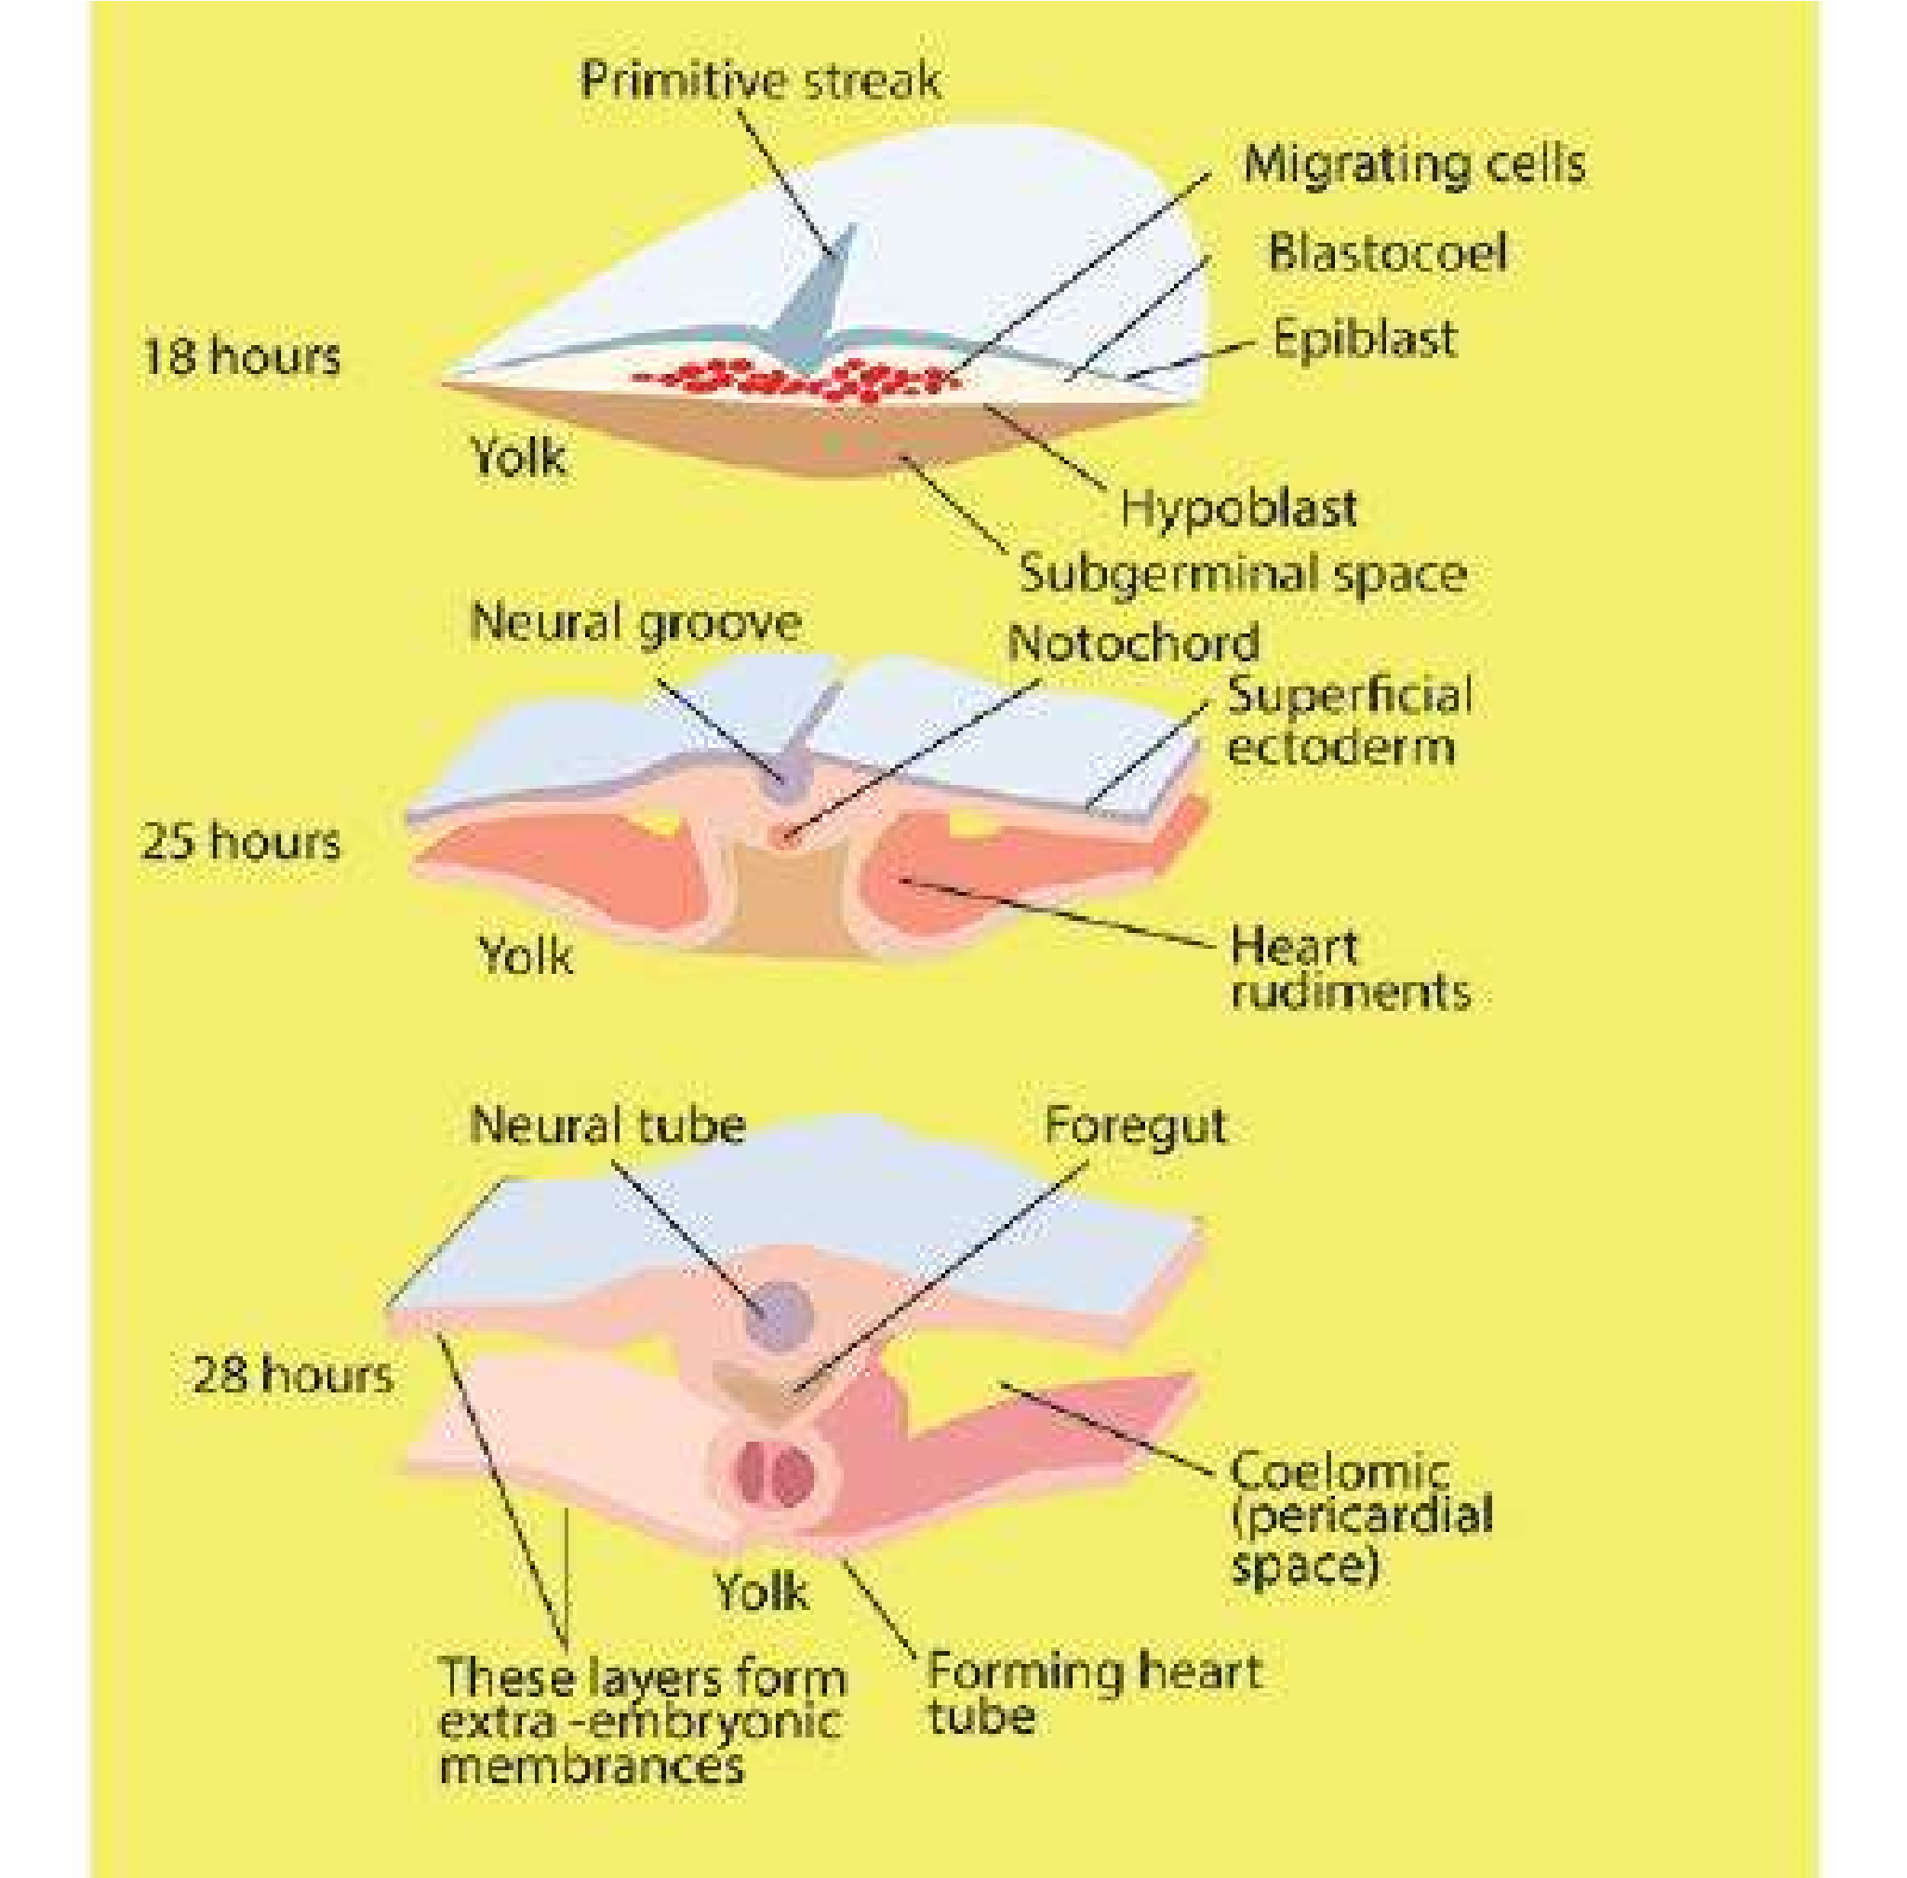

*Fig. 19.7 Gastrulation in the chick*

The anterior end of the primitive streak is occupied by an aggregation-the . primitive node or notochordal cells while rest of cells are mesodermal cells. Thus primitive streak represents the dorsal and both lateral lips of blastopore.

The continuous migration of cells takes place between epiblast and hypoblast and results in the formation of groove along the whole length of primitive streak. This is named as primitive groove, marked on either side by thickened margins, the primitive ridges.

At the cephalic end of primitive streak, closely packed cells form a local thickening known as Hensen’s node. The Hensen’s node however, mark the site of a somewhat special type of invagination.

Shortly, after the primitive streak has been formed and the endoderm was well established, cells begin to push in from the region of Hensen’s node to form the rod like notochord in the midline beneath the ectoderm. In chick embryo of about 18 hours, notochord is one of the few prominent structural features. In sections of embryo incubated from 18-20 hours, it is seen that ectoderm has spread and become organized into a coherent layer of cells merging peripherally with the yolk and the marginal area where the expanding germ layers merge with the under lying yolk is known as germ wall and the cavity between the yolk and the endoderm which has been called gastrocoele is now termed as primitive gut.

From Hensen’s node, dorsal mesoderm is formed and is organized into somites. The lateral plate mesoderm is splitted into two sheet like layers viz somatic mesoderm and splanchnic mesoderm, with a space between them. The cavity formed between somatic and splanchnic mesoderm is coelom. Somites are seen in 25-26 hours embryo, these are compact cell masses lying immediately lateral to neural folds.

**Neurulation :**

On the dorsal surface of gastrula, over the notochord, presumptive neural ectoderm is present in the form of a band. As gastrula elongates, the band thickens to form a neural plate. In chicks of 18 hours, neural plate was seen as a lat, thickened area of ectoderm. In embryos of 21-22 hours, a longitudinal folding has occurred, establishing the neural groove in the mid dorsal line, on either side of neural folds. In 24 hours embryos, the folding of neural plate is clearly visible. The embryo is now termed as neurula. The anterior end of the neural groove is widest and forms the future brain and rest of portion is future spinal cord. In the meantime, the neural plate sinks and the neural folds grow toward one another and meet in the middorsal line, fuse and convert the neural groove into neural tube. At each end of neural tube, a small opening called anterior and posterior neuro-pores are also seen, which close later on. With the formation of neural tube, there is formation of central nervous system and the cavity enclosed is known as neurocoel. This whole process is named as **neurulation.**

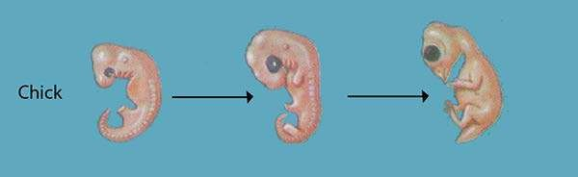

*Fig:19.8 Early chick embryos*

Mechanisms of Development

We know that from a single celled zygote, multicellular individual is formed and zygote contains complete information in the form of genome which has come in the form of chromosomes from the eggs and sperms. During cleavage, zygote divides into many cells. Each cell has full set of chromosomes and gets complete instructions from the parents. During diferentiation however some genes remain active, while others switch of. The importance of nucleus and cytoplasm during development is revealed from the following experiments.

1.In 1892, Hans Dietrisch, took sea urchin egg at two-cell stage, shook it apart and separated it into two cell. Later on, it was seen that both half embryos developed into normal larvae. Dietrisch concluded that both these cells .

2. contained all the genetic information of the original zygote.

Another experiment was performed by Spemann. He took salamander zygote, and with the help of minute ligature of human hair divided the zygote into two equal halves. The nucleus was present in one half, but the other half had no nucleus. When the developmental process continued, it was seen that cleavage was completed in the half containing nucleus but the anucleate half was not seen dividing. Eventually, when nucleated side had reached a 16-cell stage, one of the cleavage nuclei crossed the narrow cytoplasmic bridge to the anucleate side. Immediately this side started dividing.

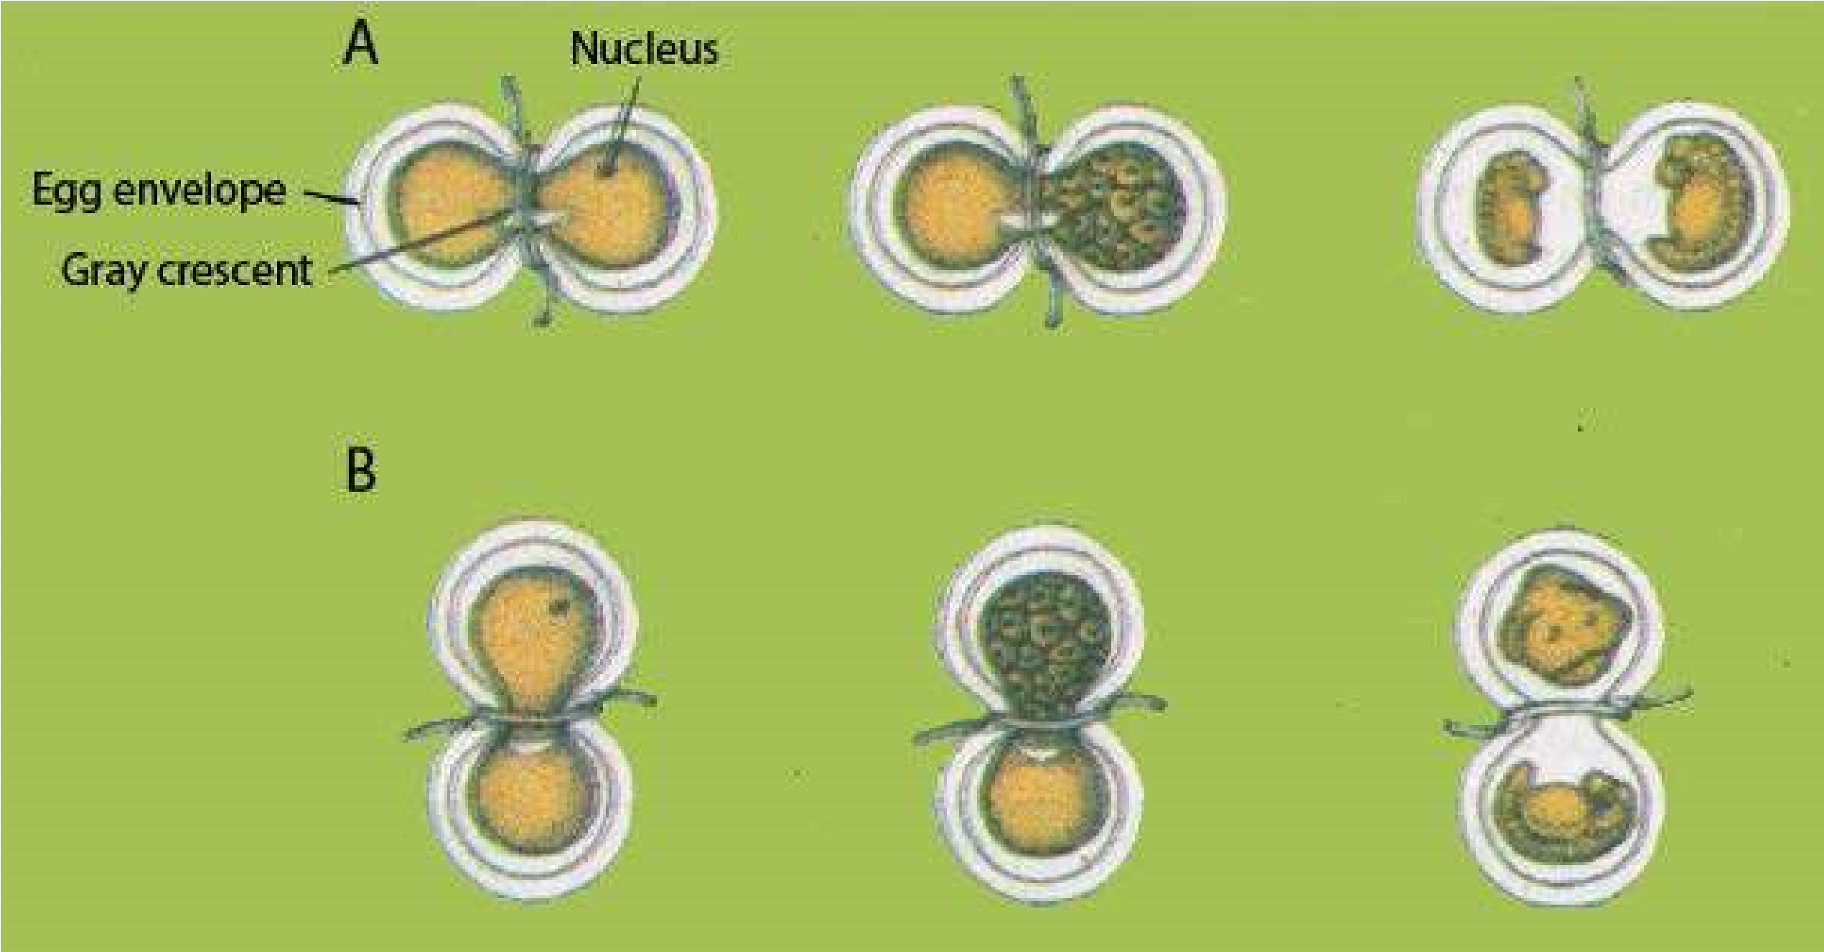

*Fig. 19.9 Spemann’s delayed nucleation experiments. Two kinds of experiments were performed. A, Hair ligature was used to constrict an uncleaved fertilized newt egg. Both sides contained part of the gray crescent. The nucleated side alone cleaved until a descendant nucleus crossed over the cytoplasmic bridge. Then both sides completed cleavage and formed two complete embryos. B, Hair ligature was placed so that the nucleus and gray crescent were completely separated. The side lacking the gray crescent became an unorganized piece of belly tissue; the other side developed normally.*

**3.**Spemann also performed another experiment. He separated the two halves of embryo; both of them contained nuclei. Both these halves developed into complete embryos. He also observed that from a 16-cell embryo even, if a single cell is separated, it contains a complete set of genes and form a complete embryo. Through series of experiments, Spemann also observed that sometimes it may happen that the nucleated half can develop into abnormal ball of cells. Later studies revealed that development depends on the position of gray crescent. Gray crescent is the pigment free area that appears at the time of fertilization. So in the half lacking gray crescent, no further development can take place.

On the basis of above experiments, Spemann made two conclusions. i) All cells contain the same nuclear information.

ii) In the gray crescent area, cytoplasm contains information essential for development. Next question is, if all the cells contain same nuclear material, what causes the cells to diferentiate. There are two ways by which cell undergo diferentiation and become committed to particular determinative molecules.

1. During cleavage, cytoplasmic segregation of determinative takes place.
2. Induction or interaction with the neighboring cells takes place.

Role of Cytoplasm in Development

It is known that diferent cytoplasmic components contain diferent morpho genetic determinants that are responsible for cell diferentiation. These determinants are present in blastomeres. The fertilized egg of an ascidian contains cytoplasm of ive diferent colours that is segregated into diferent blastomeres.

1. **Clear cytoplasm.** It produces larval epidermis. **2. Yellow cytoplasm.** It gives rise to muscle cells.

1. **Gray vegetal cytoplasm.** It gives rise to gut.
2. **Grey equatorial cytoplasm.** It produces notochord and neural tube.

Role of Nucleus in Development

Most gene controlled substances, which can easily be identiied are found in the cytoplasm, and are probably produced in it. Through experiment, it is found that production of developmentally active substances by the nucleus itself, or its immediate neighborhood, is, however available in some cases. One of such example is in the multicellular alga, Acetabularia. It consists of rhizoid, which is attached to the ground, from which arises a long stalk with an umbrella shaped cap at its top. On the basis of structure and shape of the cap, two species of *Acetabularia* have been identiied; *Acetabularia mediterranea*, which has regular shaped cap, and A. *crenulata*, which has irregular shaped cap.

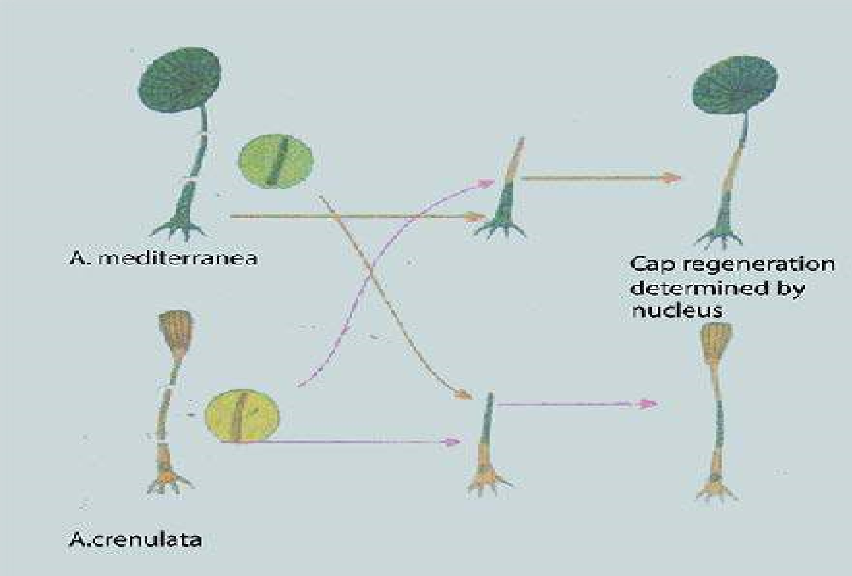

*Fig. 19.10 Nuclear control of cap structures in two species of Acetabularia.*

There is only a single nucleus, although they may attain the size of several centimeters or more. Haemmerling showed that if the cap is removed, a new one is regenerated. He cut of the nucleus containing rhizome from an alga of one species *(A. mediterranea)* and grafted a similar piece containing the nucleus of another species *(A. crenulata*). When the cap was now removed, it was seen that the new regenerated one had the characters of *A. crenulata*. So nucleus lying at the base of the alga and not the stalk to which the regenerate was attached determined the structure of cap. It means that irrespective of the fact to which species the cytoplasm belong, the genes were able to express according to the type of nucleus

From all these experiments , it was concluded that both gene and cytoplasm play important role in development . Nucleus contain all gene, which determine the characteristics of the individual, while cytoplasm plays the role of selection of genes.

**Concept of Differentiation:**

A fertilized egg contains cytoplasmic components that are unequally distributed within the egg. These diferent cytoplasmic components are believed to have morphogenetic **determinants** that control the functioning of a speciic cell type. This is now called diferentiation.Zygote contains complete information for the development of an individual but it is diicult to see, how these cells diferentiate.

In order to understand the concept of diferentiation, Spemann performed a series of experiments on amphibian embryo.

He took out piece of ectoderm from frog’s embryo and grew it in a separate dish. The embryo from which the piece of ectoderm was removed , was unable to form normal nervous system but has a defective nervous system. Similarly , the isolated piece did not develop any structure even though it was active and healthy . In another experiment , he separated the mesoderm underlying ectoderm and folded the lap of ectoderm to its original piece . The frog did not develop any nervous system. So it was proved that mesoderm had some efect on the ectoderm to simulate the ectoderm cells to form nervous system.

Embryonic Induction

The capacity of some cells to evoke a speciic development response in other is widespread phenomenon in development . Work on embryonic induction was reported by Hans Spemann and Hilde Mangold in 1924. They took two embryos of salamander at the gastrula stage and removed a piece of dorsal blastopore lip from one embryo , and transplanted it into a ventral or lateral position of another salamandar gastrula. It invaginated and developed a notochord and somites. It also induced the second embryo to form neural tube and a complete nervous system was formed where the dorsal balstopore lip was placed . The developing embryo had both the grafted tissue and induced lost time. Later on, it was seen that only cells from the dorsal lip of balstopore were capable of inducing a complete embryo . This area corresponds to the presumptive area of notochord, somites and prechordal plate. Spemann designated the dorsal lip area the **primary organizer** because it was the only tissue capable of inducing development of secondary embryo in the host . This was called **primary induction**

AGING

Aging is an inevitable process and despite all the eforts to inhibit or stop it aging process goes on . It can be deined as negative physiological changes in our body . We identify the adult individual by the following signs of old age , all of them need not be present e.g. loss of hair pigment , development of small pigmented areas in the skin of face and arms , dryness and wrinkling of skin , loss of agility , increased weight due to fat poor vision and forgetfulness , general weakness and decreased body immunity.

Degeneration of organ and tissue may also take place e.g. in joints, arthritis arises from the degenration of cartilage , degeneration and disappearance of the elastic tissues in the tunica media of the blood vessel result in arteriosclerosis , blood clotting in the coronary arteries.

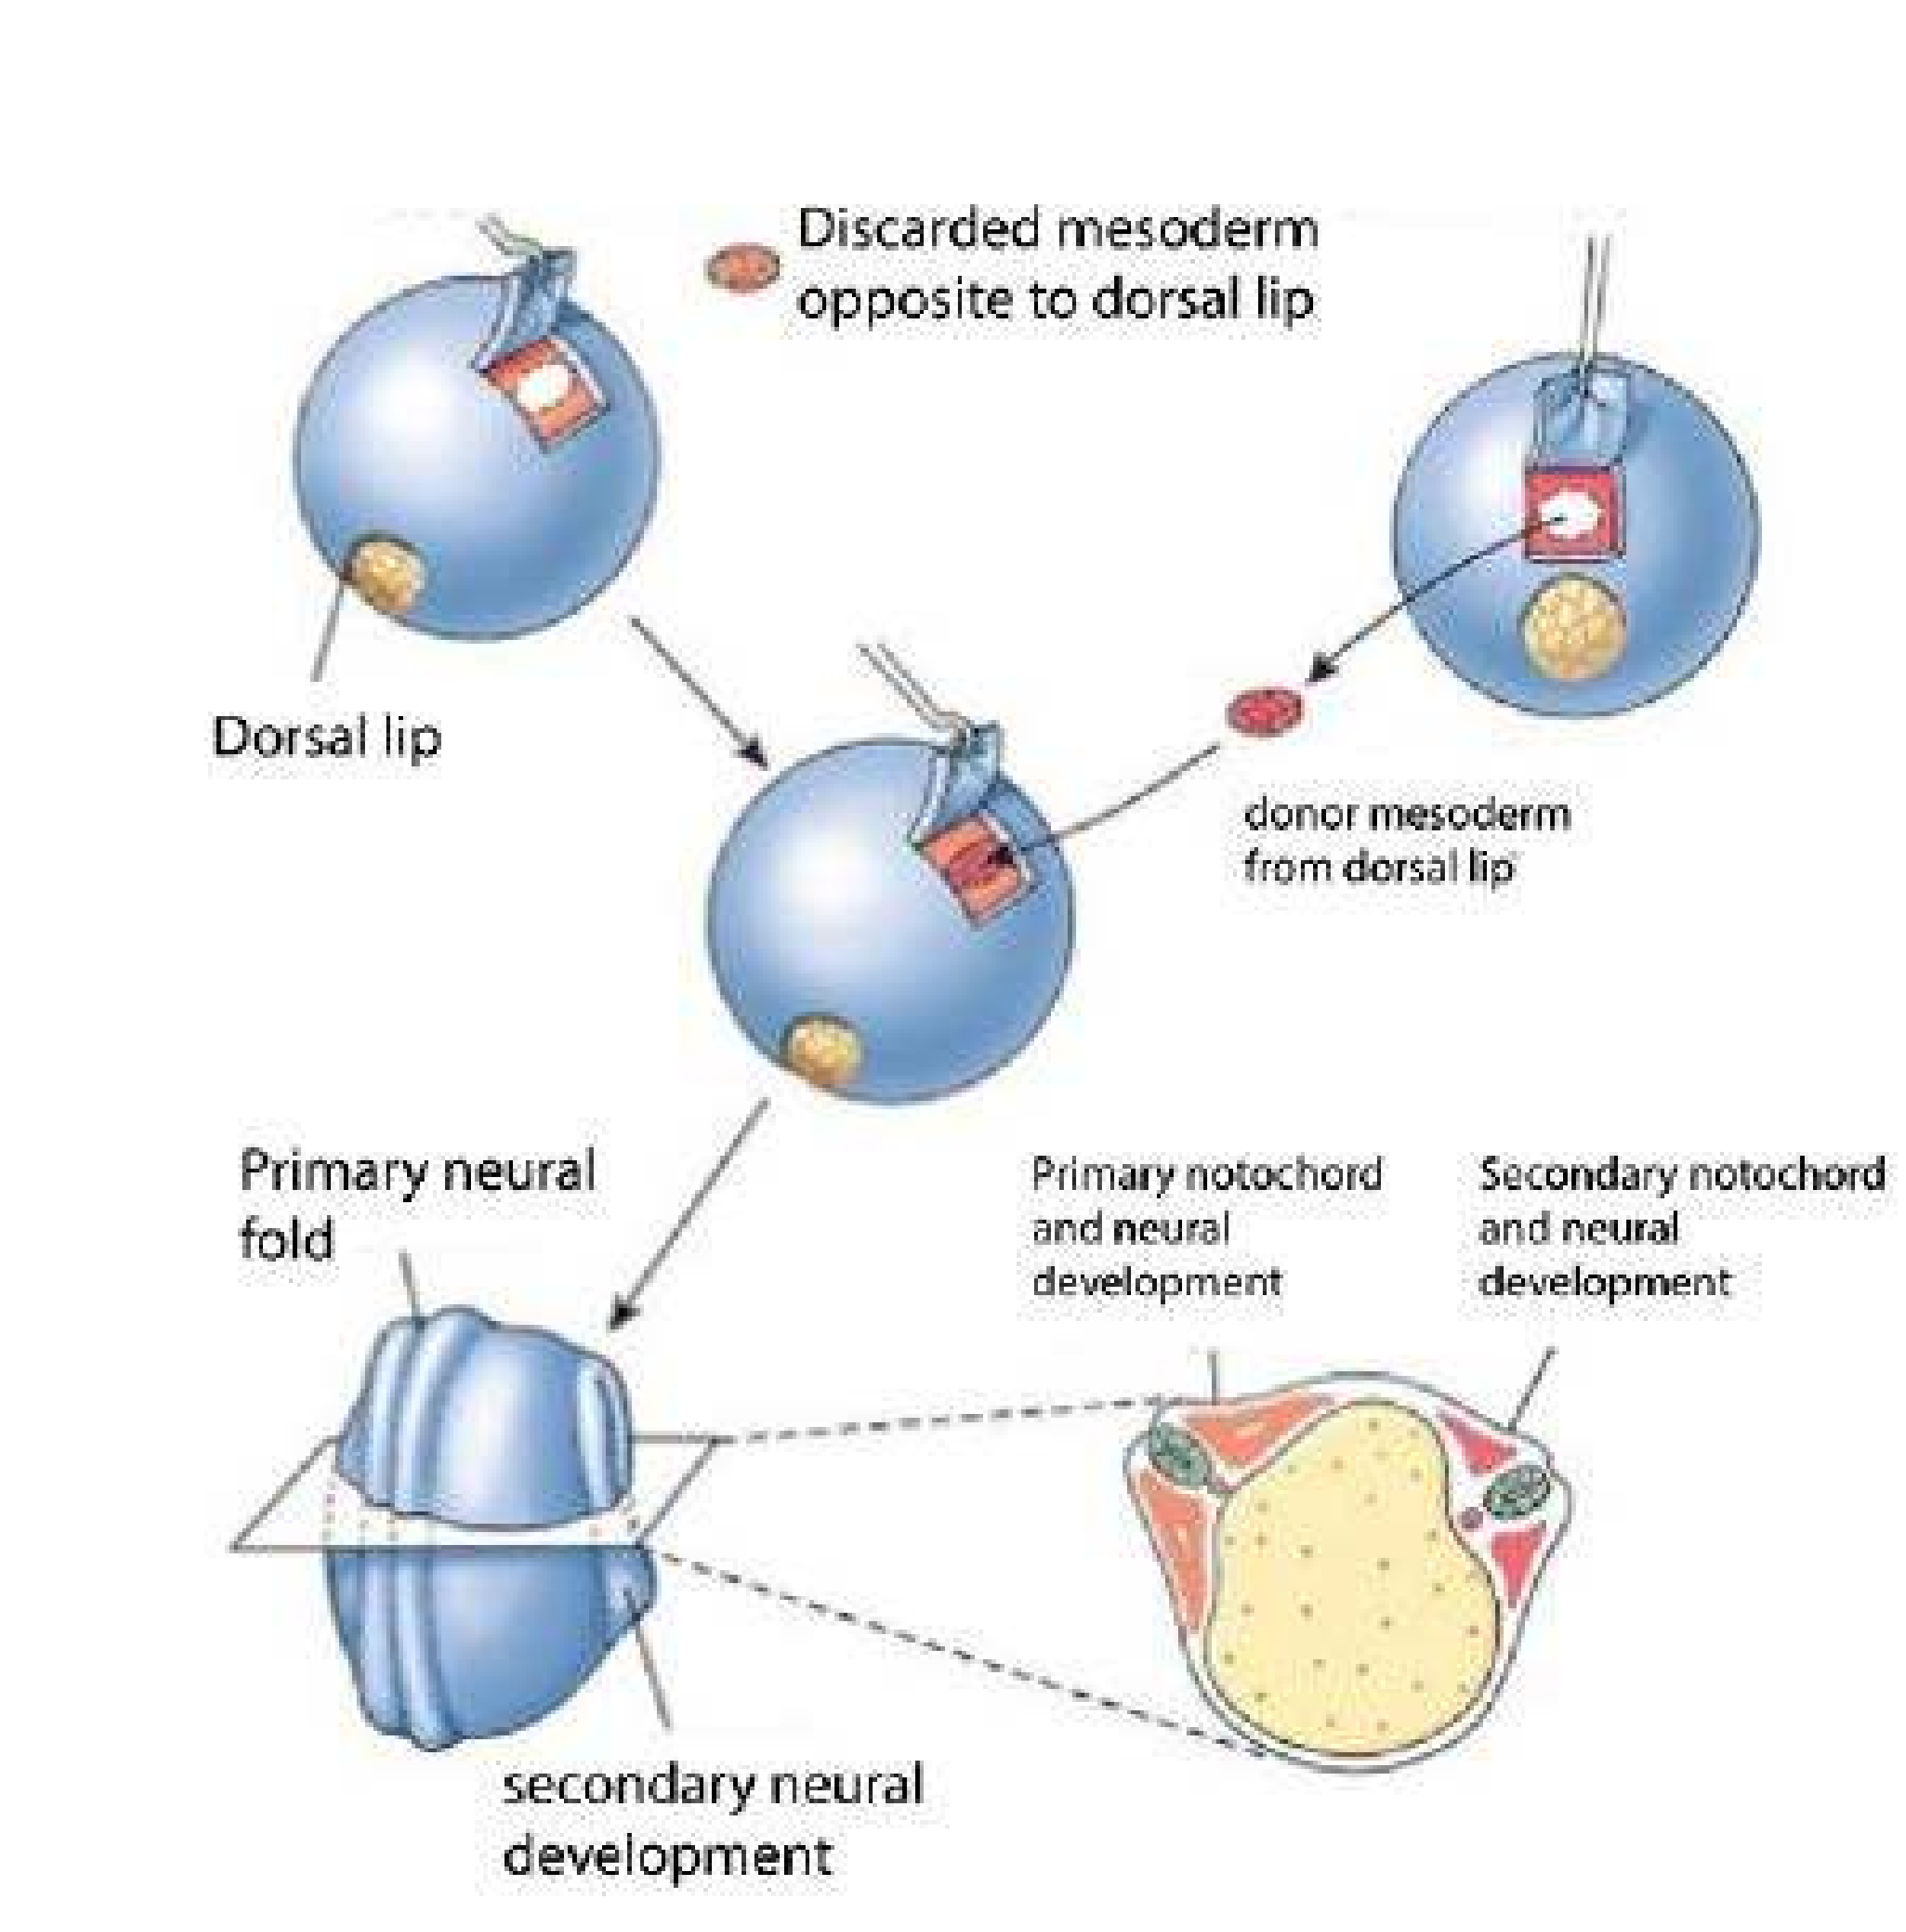

*Fig. 19.11 The spemann primary organizer experiment*

The exact process of aging is still unknown , but the following points are worth consideration.

1. The cells of tissues have only a inite number of mitotic division and hence the cells may have reached their inite number by the time tissue or organ is fully grown. For example in the case of nervous system, mental activity and memory deteriorate and there are fewer nerve cells in old age.
2. Changes in intracelluar substances take place during aging . For example, collagen acquires increased cross linkages in its protein molecules , while elastic tissues loss their elasticity with the passage of the time . There is also hardening and loss of resilience in dense connective tissues and cartilage.
3. Spontaneous mutation may result in

loss of cells and degeneration of tssues . Today, there is a great interest in The process of aging can be slowed down gerontology, the study of aging. The by better nutrition and improved living number of older individuals are expected conditions e.g. regular meals, regular to rise. In the next half century, the exercise , adequate sleep , abstinence from number of people over age 75 will rise smoking and maintaining ideal weigth can from the present 8 million to 14.5 million prolong life by an average of 11 years. ,and the number of over age 80 will rise from 5 million to 12 million. The human life span is judge to be maximum of 120125 years. The present goal of gerontology is not necessarily to increase life span but to increase health span.

REGENRATION

The ability to regain or recover the lost or injured part of the body is called **regeneration** .In sponges due to simple organization sponges possess greate power of regeneration . These not only replace the parts lost during injury , but any piece of the body is capabale of growing into a complete sponge. The process, is however , very slow and requires months or years for the complete development .

If lobster loses its pincer claw a new claw regenerates. If starish breakes of portions of their arms into pieces till the central disc completely devoid of arms is left , the central disc in almost all cases and also the arms in some cases are capable of developing into separate individuals. If head of earthworm is removed, a new head regenerates. Limb regeneration has been studied mostly in salamanders of various ages. In these forms, the limbs are readily regenerated throughout life, more rapidly when the amphibian is young and small. Besides limb, other parts of the body also have considerable regeneration capacity e.g. tail in the larva of amphibians and in lizards. For example, lizard can easily discard its tail but tail can be regenerated by special features of its tail.

Healing of fracture and repair of a skin wound are some other examples of regeneration.

In plants, regeneration is the basis of plant propagation. Almost any part or even a very small fragments of a plant e.g. a piece of stem or leaf or even a single tissue cell may develop” into a full plant. A part of the stem with a few leaves may be taken from many kinds of plants and when planted in soil form a complete plant.

*Animation 19.3: Regenration*

*Source & Credit:* [*Giphy*](http://http://giphy.com/gifs/project-ed-regenerate-vocabgifs-jtk1kOk751LEI)

In the process of regeneration, many of the various cell types which were present in the missing part of the body are replaced by the diferentiation of cells e.g. in latworms, and planaria the unspecialized cells, neoblasts, which are always present in the body of adult are mobilized and migrate to the site of amputation, where they diferentiate into specialized cell types. But in other organisms like salamanders or newts some of the specialized tissue cell types in the stump of an amputated limb apparently dediferentiate (become less specialized) and then proceed to diferentiate into the same and probably diferent types of cells.

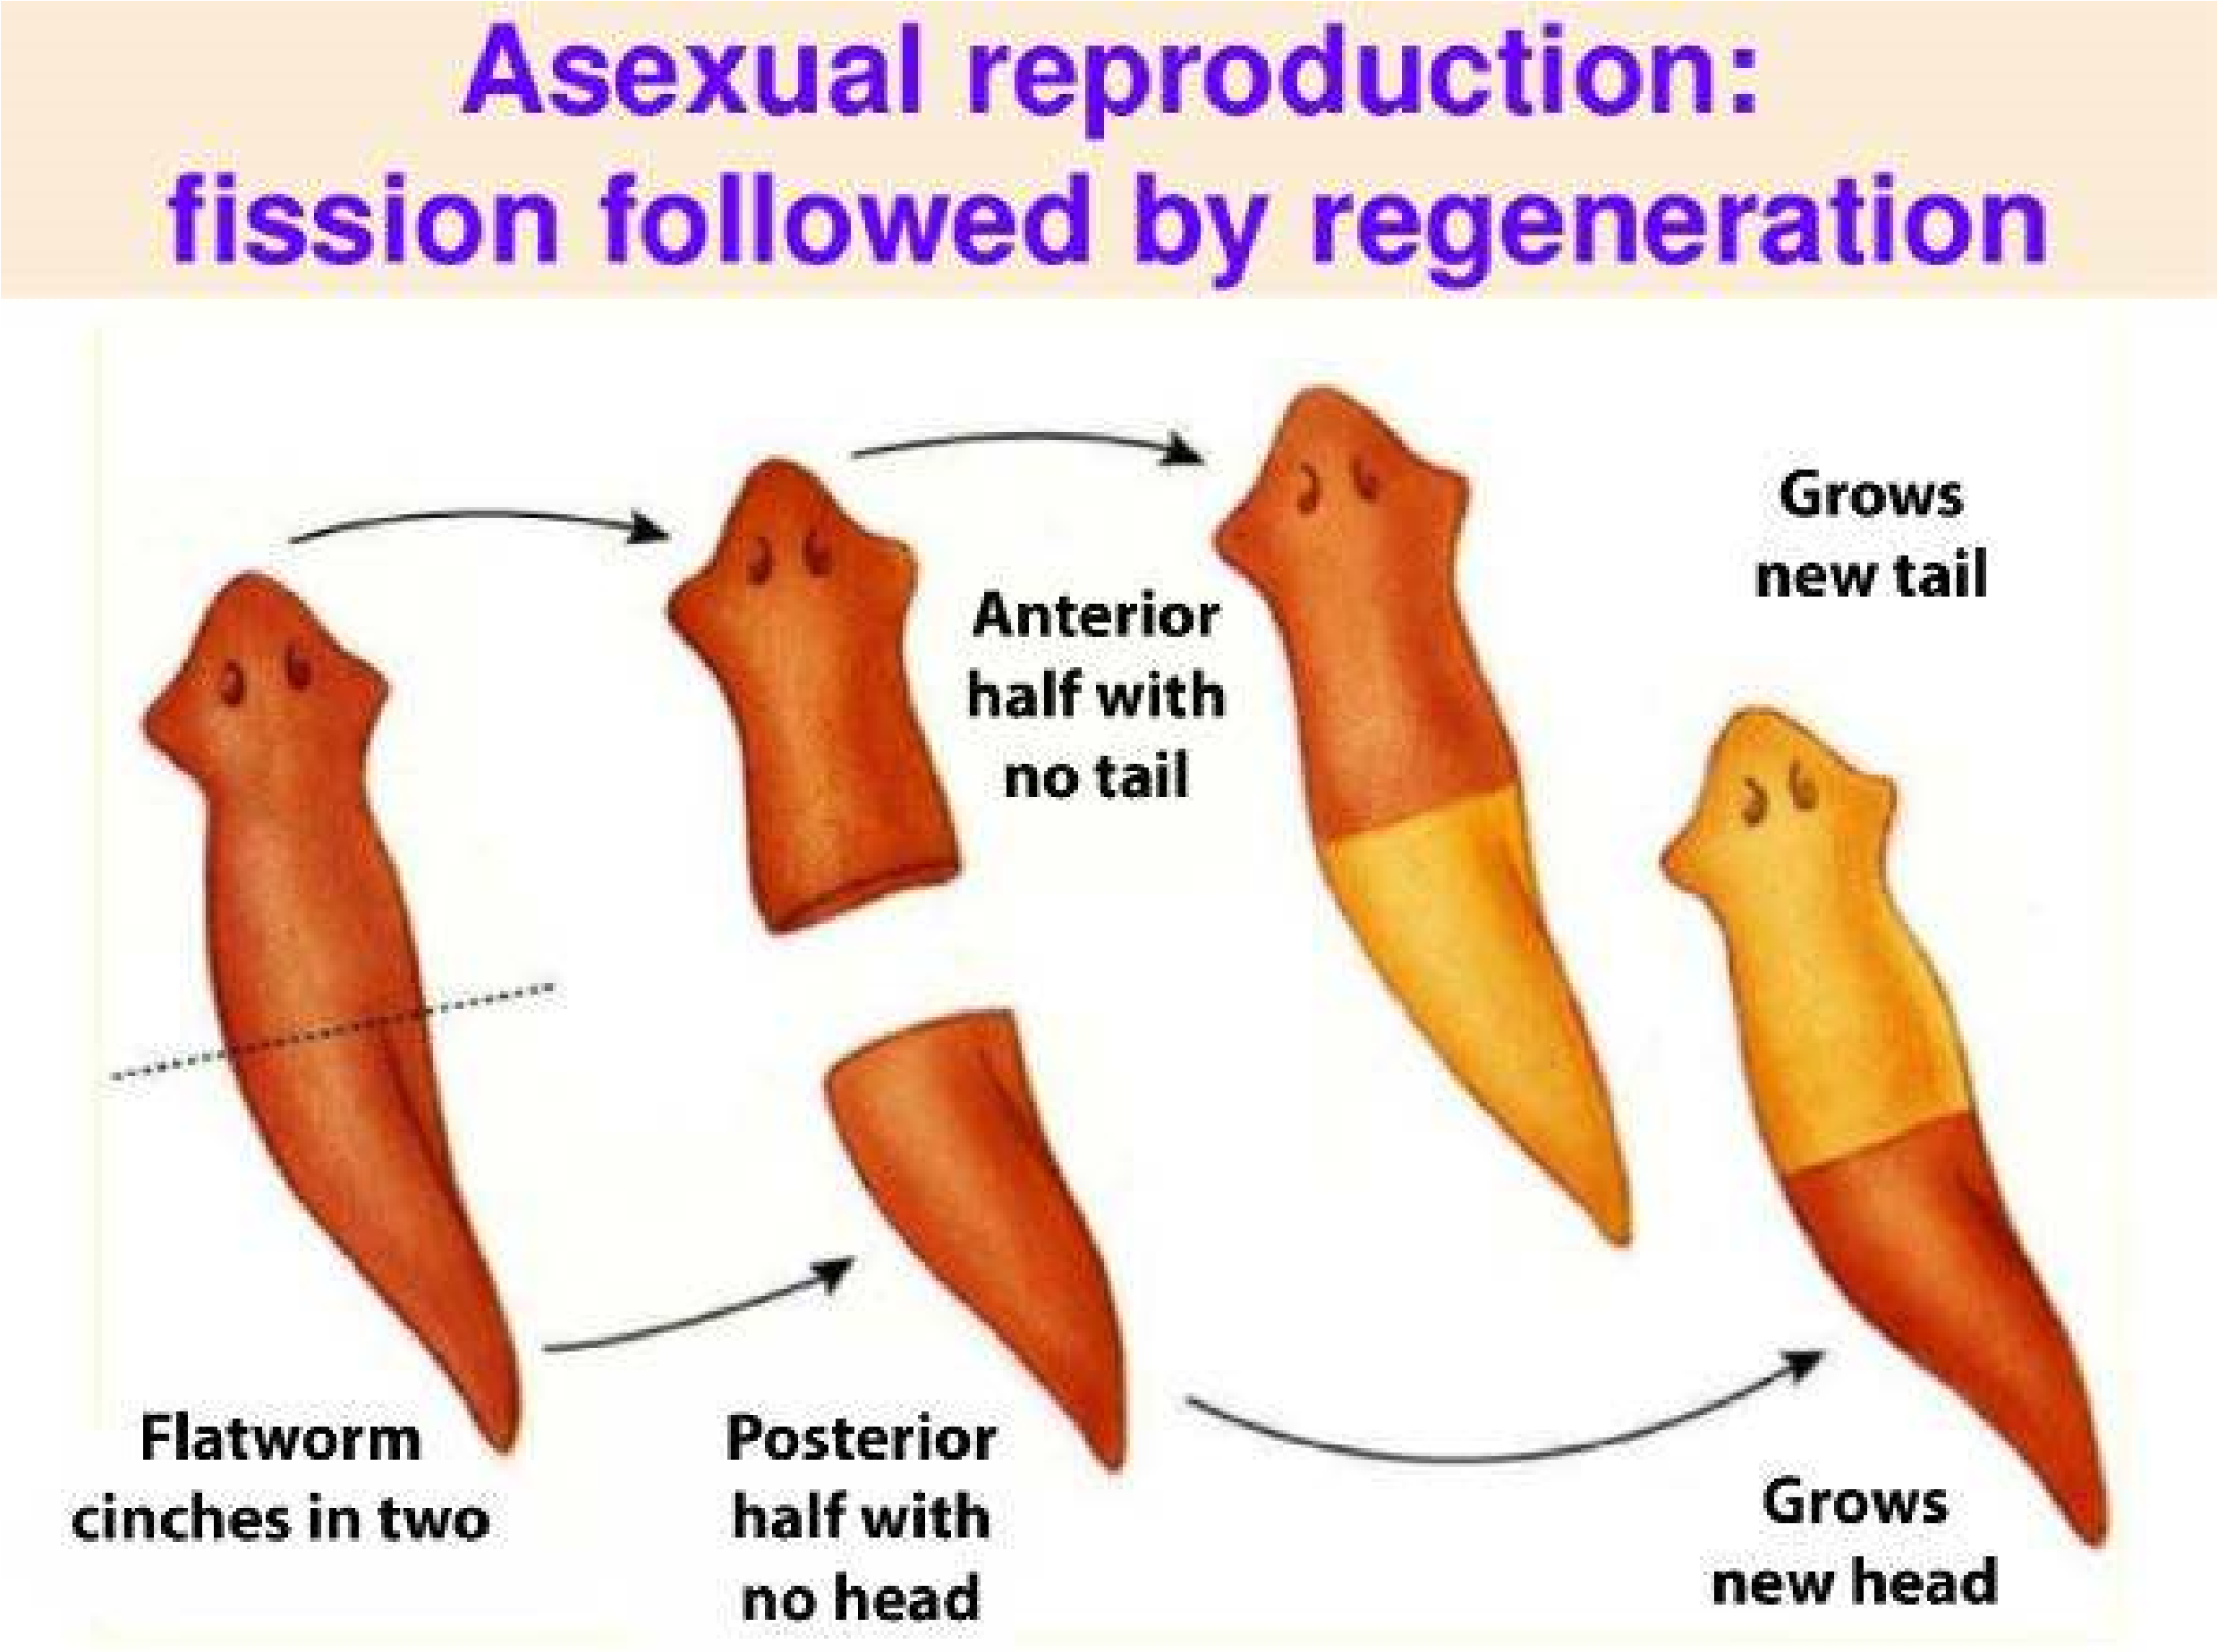

*Fig:19.12 Regeneration in (a) Start ish (b) Planaria*

ABNORMAL DEVELOPMENT

Sometimes, under unfavourable conditions, some parts of the body show abnormal development. Teratology is the branch of biology, which deals with these abnormal developments and causes for such developments. Anything which interferes with the normal process of development is the factor causing abnormalities.

The normal process of development is disturbed by abnormalities inherited from parents, abnormalities due to chromosomes or genes, environmental factors or metabolic defects.

Abnormalities are inherited from parents through abnormal or defective gene(s). Abnormality of development is also related to the presence of defective gene on sex chromosomes e.g. in haemophilia only males sufer from this disease. It again, depends whether the gene is dominant or recessive, homozygous or heterozygous.

Chromosomal abnormalities result when one of the sex chromosomes (x or y) is missing or extra and these abnormalities lead to syndromes. Kline-felter’s Syndrome (xxy) is an example of trisomy of the sex chromosome while Turner’s Syndrome (xo) is the condition in which one of the sex chromosomes is missing. Another condition, xyy leads to tallness, aggressiveness, mental defect and antisocial behavior. These abnormalities arise during the formation of gametes, when these gametes unite to from zygote.

Environmental factors causing or contributing to abnormal development are grouped together as teratogens. Ionizing radiations (e.g. x. rays) are well known for their teratogenic action. Because, they often have their efect on the developing ovum or spermatozoan, causing damage or changes (mutations) in the genes. Nutritional deiciencies, absence of certain substances (e.g. vitamins and trace elements), toxins and drugs even ingested by mother, efect the diferentiation of every tissue in the foetus. If such deiciency is high, a cell may cause death of foetus.

Metabolic defects lead to structural deviations from the normal. During

organogenesis, when various body organs are formed, sometimes, one organ or its part is missing or it is repeated and it can result into abnormal organs or body parts and the individual born are malformed.

In microcephaly, the individuals are born with small skull. Individuals with cleft palate have their upper lip folded or the individual has harelip. In conditions of the ingers in hand or feet are more or less than ive.

**EXERCISE**

**Q1. FIll in the blanks.**

1. The inluence of notochordal cells on the ectodermal cells to become nervous system was called____________ .
2. _____________is a condition in which individuals have small skull.
3. Growth is accompanied by two factors.

(a) by increase in _______________(b) increase in_____________.

1. ______________are the regions where growth is initiated by the proliferation **of cells.**

**Q.2 Write whether the statement is true or false and write the correct statement if false.**

i). Primary growth leads to increase in length, while secondary growth leads to increase in width. ii). The plants in which lowering is not at all efected by the day length are called day neutral plants. iii). The somatic mesoderm soon splits in the middle to form two layers

(a) Outer parietal layer (b) Inner visceral layer

iv). In the clear cytoplasmic area, cytoplasm contains information essential for development.

v) The phase of cell movement and rearrangement is called cleavage.

**Q.4 Short questions.**

1. What is organizer and inducer substance?
2. What is diferentiation?
3. Deine embryonic induction.
4. Diferentiate between growth and development.(v) What is meristem?

**Q.5 Extensive questions.**

1. What is aging. How will you explain this process.
2. What is regeneration? Why it is so efective in some animals and missing in others?
3. Describe in detail the developmental processes of chick.
4. What is growth, discuss diferent phases and condition for growth?
5. What is development, describe the principles of development in detail?